

[Document title]

[Document subtitle]



[Date]

[Company name]

[Company address]

Contents

List of Figure 1

Question 03 2

Code 2

Output 3

Question 04 4

Code 4

Output 5

# List of Figure

Figure 1: Output Q 03 2

Figure 2: Graph 4

# Question 03

## Code

clear

clc

T=0:12;

D=[0,2,5,8,15,28,32,49,57,68,110,109,130];

vf=[];

af=[];

vb=[];

ab=[];

vc=[];

ac=[];

n=length(T);

for i=1:n-1

vf(i)=D(i+1)-D(i);

end

disp('Velocity using forward difference is');

disp(vf);

for i=2:n

vb(i-1)=D(i)-D(i-1);

end

disp('Velocity using backward difference is');

disp(vb);

for i=2:n-1

vc(i-1)=(D(i+1)-D(i-1))/2;

end

disp('Velocity using central difference is');

disp(vc);

for i=2:n-1

ac(i-1)=D(i+1)-2*D(i)+D(i-1);

end

disp('Acceleration using central difference is');

disp(ac);

for i=3:n

ab(i-2)=D(i)-2*D(i-1)+D(i-2);

end

disp('Acceleration using backward difference is');

disp(ab);

for i=1:n-2

af(i)=D(i+1)-2*D(i+1)+D(i);

end

disp('Acceleration using forward difference is');

disp(af);

## Output

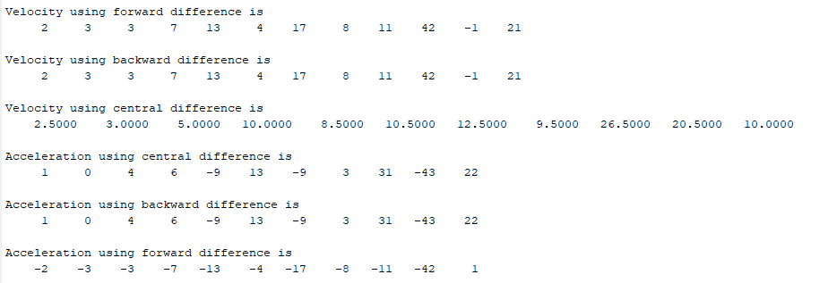

Figure : Output Q 03

# Question 04

## Code

clc

clear all;

close all

XYZ=426

f1=@(x)(-3.8*(x -XYZ)^2 -8.6*(x -XYZ) -500-XYZ);

a=f1(0);

f2=@(x)(-3.8*(x -XYZ)^2 -8.6*(x -XYZ) -800-XYZ);

b=f2(0);

c =426;

loop_limit=20;

itera_trapz = [zeros(1,loop_limit)];

itera_simp = [zeros(1,loop_limit)];

itera_rect = [zeros(1,loop_limit)];

for i = 1:loop_limit

med = (b-a)/i;

rect_sum = 0;

for j = 1:i

A = a + j*(med)-(med/2);

B = sqrt(((A^2)-(c^2)))/A;

rect_sum = rect_sum + B*med;

end

itera_rect(i) = rect_sum;

med = (b-a)/(i-1);

trapz_sum = 0;

for j = 1:i

A = a + ((j-1)*med);

B= sqrt(((A^2)-(c^2)))/A;

if (j == 0)||(j== i)

coeff = 0.5;

else

coeff = 1;

end

trapz_sum = trapz_sum + (coeff*B*med);

end

itera_trapz(i) = trapz_sum;

simp_sum = 0;

for r = 1:i

X = a + ((r-1)*med);

Y = sqrt(((X^2)-(c^2)))/X;

if (mod(r,2) == 0)

coeff = 4;

else

coeff = 2;

end

if (r == 0)||(r == i)

coeff = 1;

end

simp_sum = simp_sum + (coeff*Y*med*(1/3));

end

itera_simp(i) = simp_sum;

end

plot(itera_rect)

title('Plot Errors with Iteration ');

xlabel('===>loop_limit');

ylabel ('====>Errors');

grid on;

hold on;

plot(itera_trapz);

hold on;

plot(itera_simp);

hold on

legend('Rectangle','Trap','Simp');

## Output

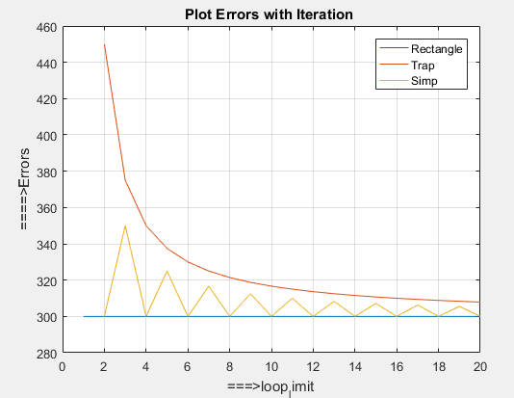

Figure : Graph